

Owned By Brian Doyle

Website Created By Jeff Carroll

**Description**

**Who is Next Lvl Sports Institute?**

With the tech industry changing at such a rapid rate, the rest of the world has to race to keep up. The company *Next Lvl Sports Institute (NLS)* seeks to grab ahold of this fast-pasted tech industry in order to launch their business to the next level. *Next Lvl Sports* specializes in using state of the art fitness programs and training curriculums to provide the best service to their customers.

**Goals of www.NextLVlSports.net:**

The goals of “www.nextlvlsports.net” are to provide an online, state of the art, fitness and spiritual curriculum designed to take the trainee from novice to professional and beyond. The website will act as a central location for the *NLS* Instituteand will allow the student to track their progress. There will be a series of different features that enable *NLS* to monitor individuals and groups differently.

**Groups and Individual Features:**

Per the requirements of a web based curriculum there will be two categories of accounts.

* **Online Account**
  + The online accounts will have the capability to view others and their Training Statistics but not participate in the social competition of Statistics.
* **Campus accounts**
  + The campus account will have two categories and will be able to participate in competition.
    - **Trainee Accounts –** This will be the individual based account that keeps a record of the trainee’s statistics.
    - **Class/Team Accounts –** This will be a group of trainees that work together in a class format
  + Class and Trainee Accounts will have the capability to compete with other class trainees for the best statistics in the institute.

**Target Market:**

*NLS* has a wide customer base. From 8 years old, all the way to instructor qualifications, there is no limit to what you can learn through *Next Lvl Sports Institute*. “The NLS Website” must have the capacity and the control to handle the diversity of their target market of Parents, Students and Professionals.

**Dashboard**

The purpose of the dashboard is to provide the end user with their home page of functions, which they can use inside their web application.

**Trainee Dashboard**

For the trainee, the dashboard is going to take a snapshot of several different things:

1. The type of training session that the student is enrolled in.
2. The length of time that the student is going to be working on the specified tasks with the training program.
3. The Dashboard will illustrate the mastery, skill level and the specified drill that the student has trained on a particular day.
4. The above stated, will have been taking in to account the player’s stats which will be a snapshot window on their dashboard.

**Class / Team Dashboard**

The Class Dashboard will display the overall stats for each player on that team, unless the player otherwise requests them to be private.

**Color Scheme**

|  |  |  |  |
| --- | --- | --- | --- |
| Macintosh HD:Users:jeffreycarroll:Desktop:PWA2Wk1:images:color_palete:blue.png | Macintosh HD:Users:jeffreycarroll:Desktop:PWA2Wk1:images:color_palete:gray.png | Macintosh HD:Users:jeffreycarroll:Desktop:PWA2Wk1:images:color_palete:green.png | Macintosh HD:Users:jeffreycarroll:Desktop:PWA2Wk1:images:color_palete:red.png |
| Blue | Gray | Green | Red |

**Next Lvl Sports Institute Font:**

Heading and Body Copy - Jura

**Buttons**

**Normal State**

**Hover State**

**Logos**



Macintosh HD:Users:jeffreycarroll:Desktop:PWA2Wk1:images:color_palete:logo_small.png

**Wireframes**

Login Page

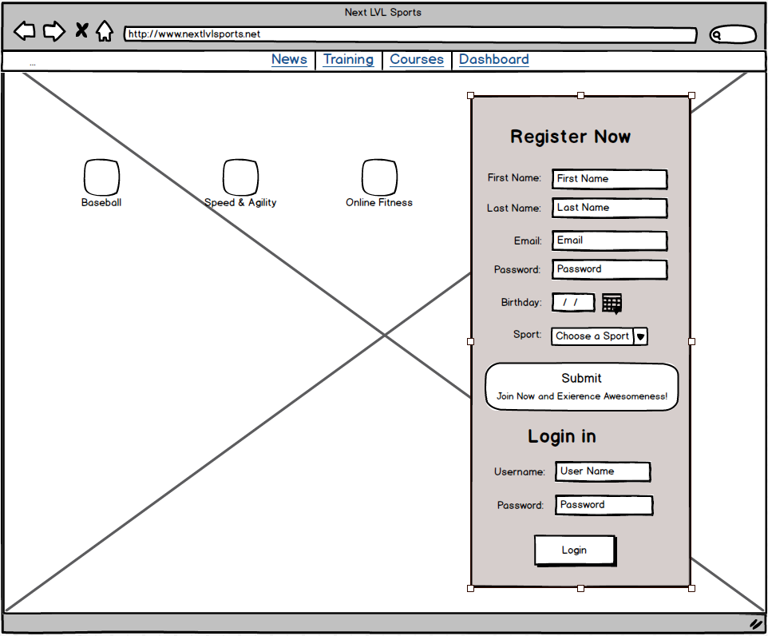

Dashboard Page

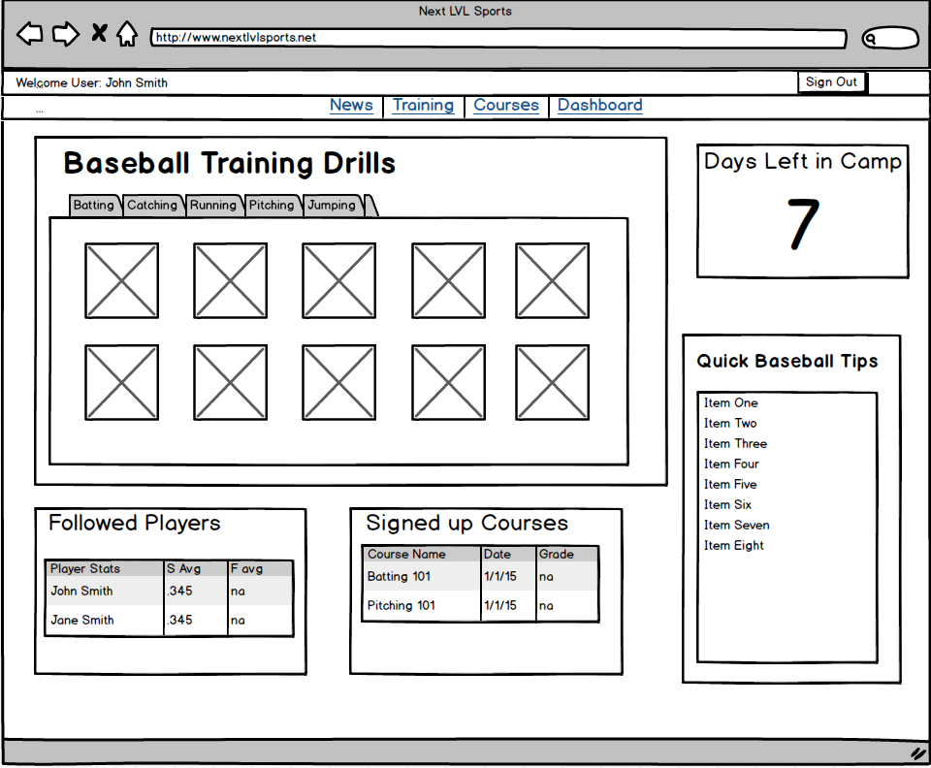

­­Register Page

